Question 1:
https://www.hackerearth.com/problem/algorithm/digit-sum-4/


Question 2:
https://www.hackerrank.com/challenges/find-digits/problem
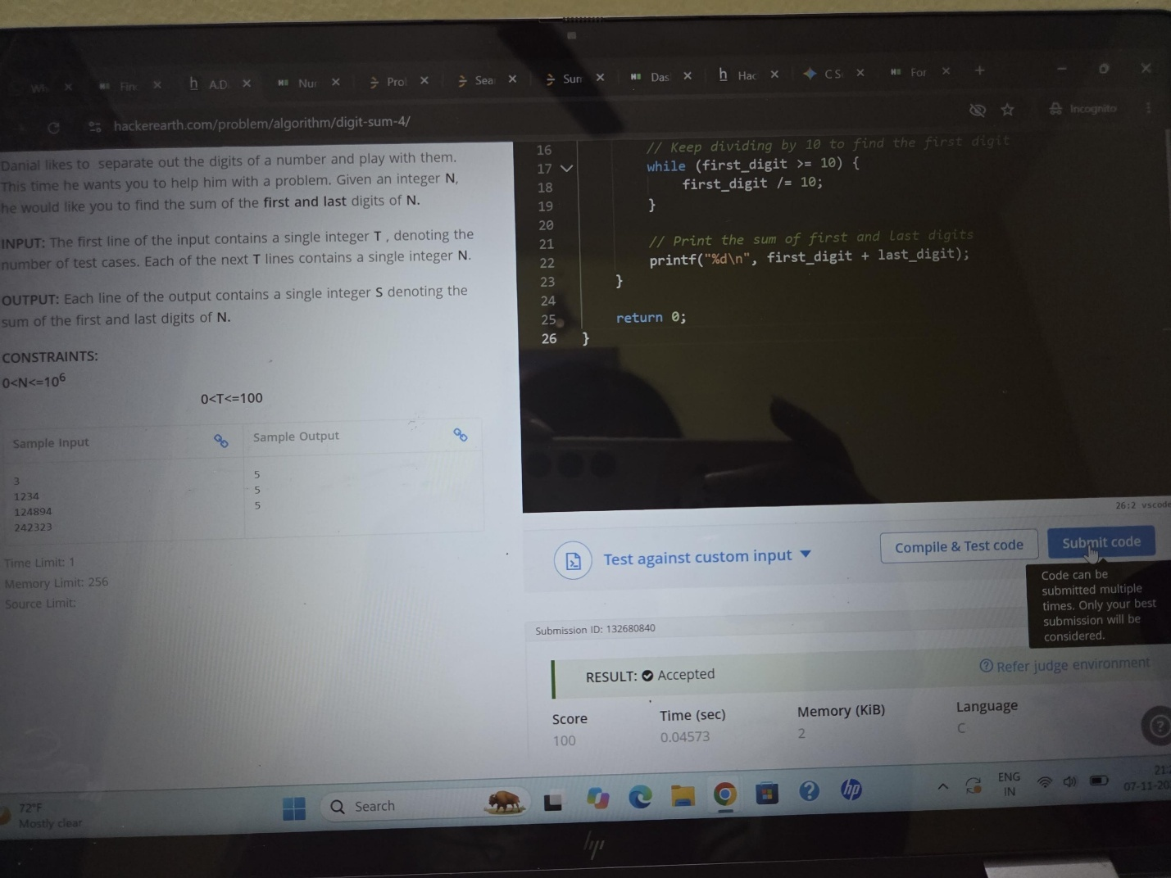

Question 3:
https://leetcode.com/problems/subtract-the-product-and-sum-of-digits-of-an-integer/submissions/2191417456/
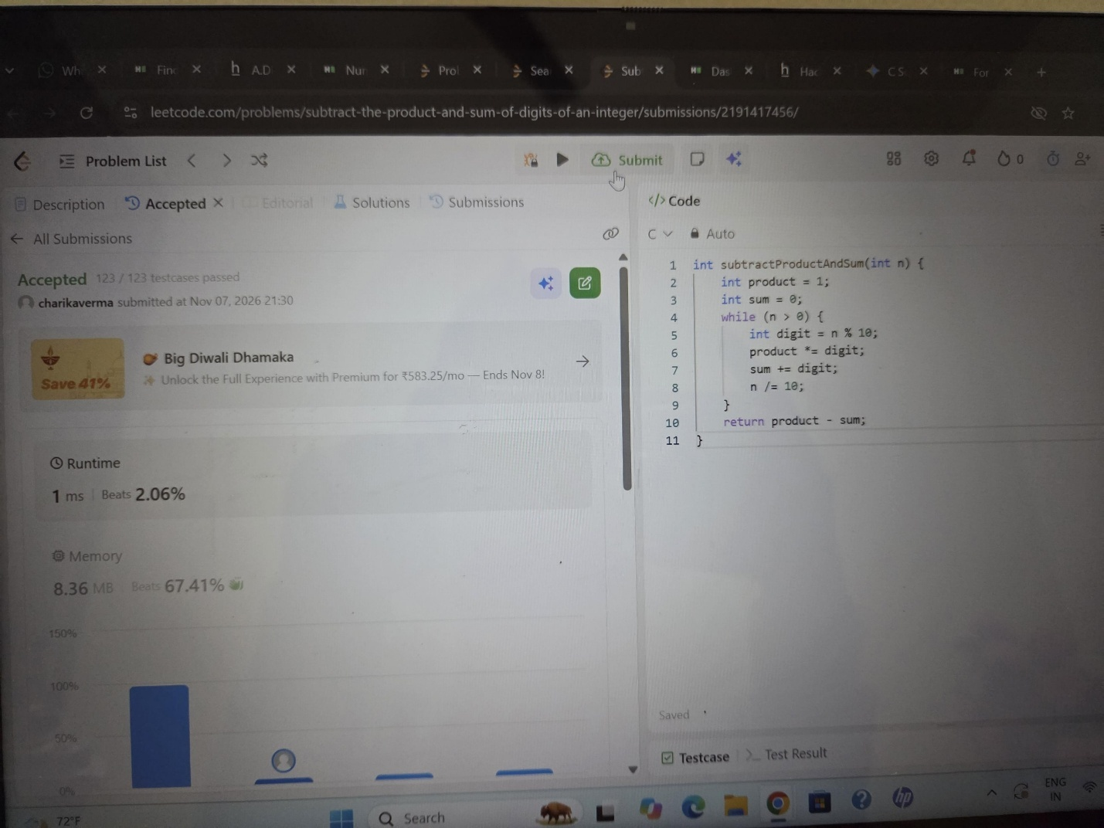

Question 4:
https://leetcode.com/problems/count-ways-to-group-overlapping-ranges/submissions/2191418149/
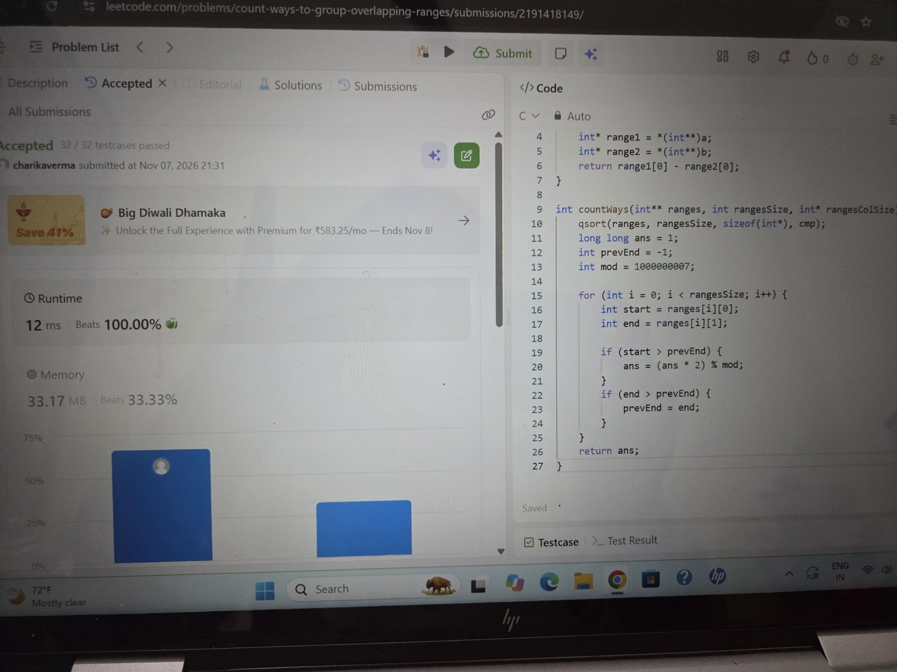

Question 5:
https://leetcode.com/problems/palindrome-number/submissions/2191418767
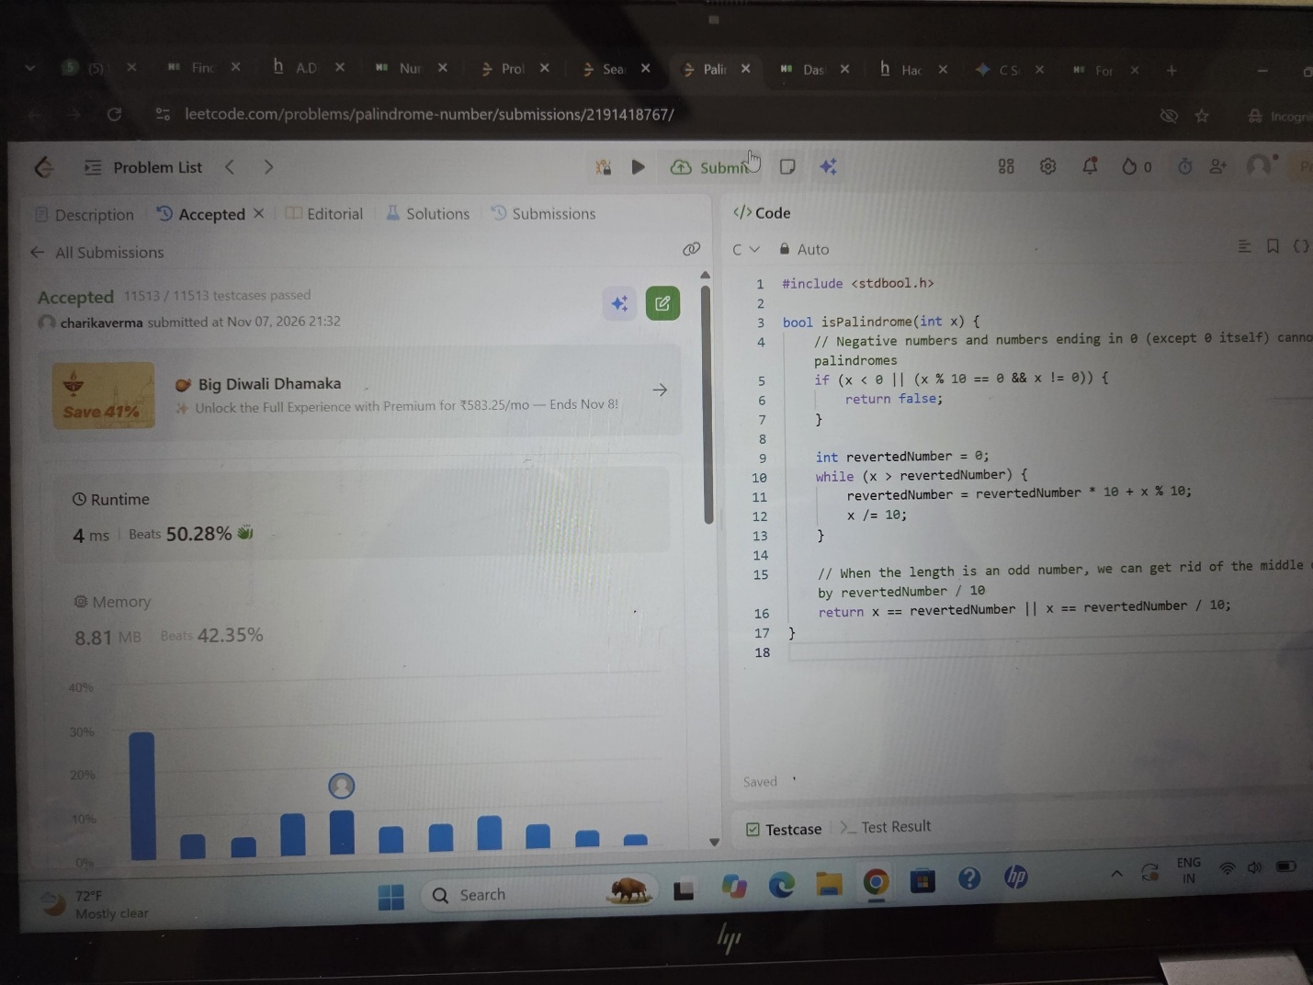

Question 6
https://leetcode.com/problems/reverse-integer/submissions/2191419224/


